CONFIDENTIAL INFORMATION

Today’s Date: _____________________

Name: ____________________________________________Date of Birth:________________________

Address: ______________________________________________________________________________

City: ___________________________________ State: _____________ Zip: _______________________

Phone: (H) ___________________________________ (C) ______________________________________

Occupation: ______________________________________ How long: ____________________________

Height: ___________________ Weight: _______________________ BP: __________________________

Emergency Contact: Name/#/Relation: ______________________________________________________

Referred By: ___________________________________________________________________________

Email: ________________________________________________________________________________

Please check any of the following that apply to you—in the past mark (P) or currently mark (X):

___ Heart Problems ___ Arthritis ___ Spinal Problems
___ High Blood Pressure ___ Osteoarthritis ___ Disc Problems
___ Heart Attack ___ Stroke ___ Knee/Shoulder Injuries
___ Blood Clots ___ Back Problems ___ Accidents or Injuries
___ Varicose Veins ___ Pregnant ___ Major Illiness/Disease
___ Pacemaker ___ Diabetes ___ Breaks/Sprains
___ Neurological Problems ___ Surgery ___ Cancer
___ Headaches ___ Epilepsy or Seizures ___ Skin Conditions
___ Allergies ___ Bruise Easily ___ Sleeping Conditions
___ Whiplash ___ Chemical Dependency ___ Constipation/Diarrhea
___ Auto-Immune Disorders ___ Depression, Panic Disorder
(AIDS, Fibromyalgia, Chronic or Other Physiological Issues
Fatigue, Lupus, etc.)

Please list any medications (prescription or O.T.C.), vitamins and supplements you are currently taking:
_____________________________________________________________________________________
_____________________________________________________________________________________
Are you currently under the care of a physician, chiropractor or alternative medicine practitioner? If yes, what are you being treated for? _____________________________________________________________________________________
_____________________________________________________________________________________

Circle any areas you may be experiencing pain or discomfort.

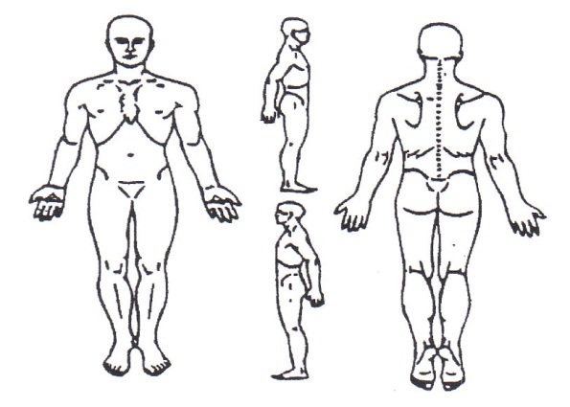

Please describe any pain or discomfort you may be experiencing: ________________________________
_____________________________________________________________________________________

Is there anything else about your health history that you think would be useful for your massage practitioner to know to plan a safe and effective massage session for you? ________________________
_____________________________________________________________________________________

Release Form
I understand that the purpose of massage therapy is for relaxation and to reduce muscular tensions and that it is not meant to diagnose or treat any illness, disease or any other physical or mental disorder, injury or condition. I have informed my therapist about my health history and have answered the questions, to be as I know it, true and accurate. I know that any recommendations from the therapist are just suggestions and they are not a means of a prescription. I understand that if I cancel a session less than 24 hours in advance, I will be billed for that session.

The Client/Patient assumes full responsibility for their injuries. They or any member of their family fully releases Advanced Muscular Therapy, it’s owner or any of it’s therapists from any and all claims, demands, damages, rights of action, or cause of action, present or future and accept full responsibility for any injury that may occur by receiving treatment at this facility. Whether the same is known or unknown, anticipated, resulting from or arising out of the client/patient use or intended use of
the facility and equipment thereof.

By the execution of this agreement, the Client/Patient assumes full responsibility for any such injuries or damages which may occur to the Client/Patient in or about the premises. The Client/Patient expressively agrees that Advanced Muscular Therapy, it’s owner, any of it’s therapists and the landlord of the property shall not be liable for any damages arising from personal injuries sustained by the Client/Patient in or about the premises. The Client/Patient does hereby fully and forever release and discharge Advanced Muscular Therapy, it’s owner or any of it’s therapist from any and all claims, demands, damages, rights of action or cause of action present or future.

The Client/Patient agrees that he/she has read and fully understands this release form.

Client/Patient Signature: _______________________________________________ Date:____________________
(Patient is responsible for payment not covered by insurance)

